Example Using Response Outreach Area Mapper (ROAM)

- To get started, go to www.census.gov/ROAM
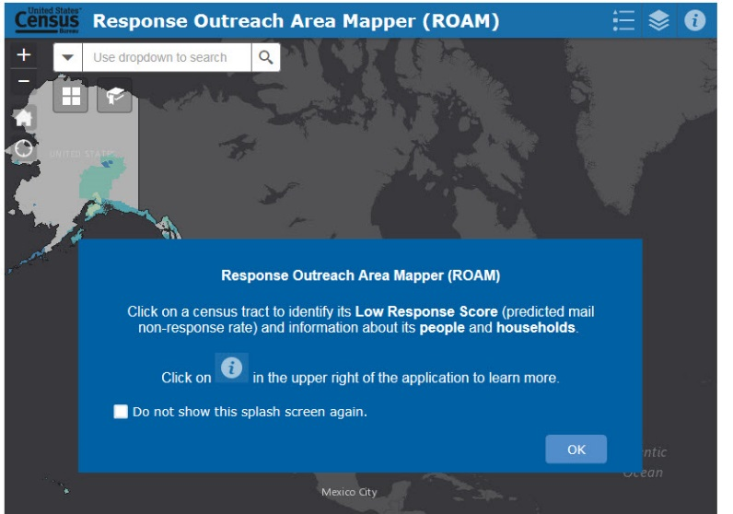
Click ‘OK’

- Buttons and Features of the Application
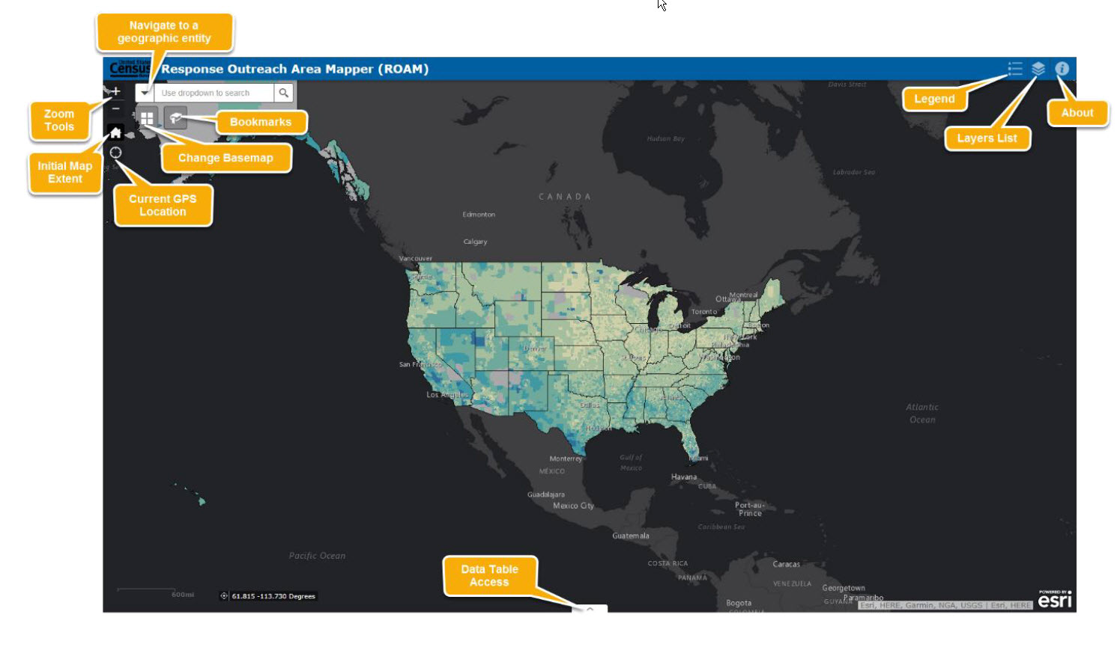

- Use Drop-down menu to select a geography (in this example, select ‘County’)
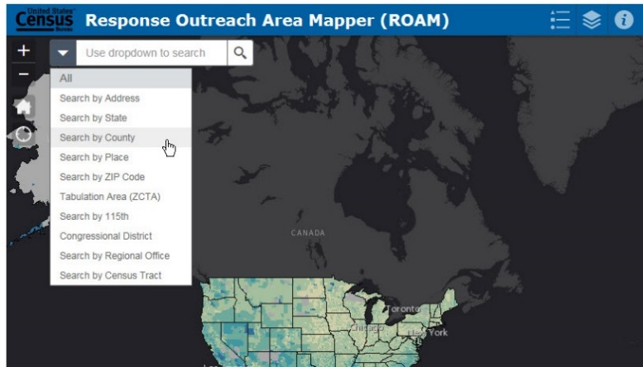

- In the text box, type the name of a geography (in this example, type ‘Sacramento County’
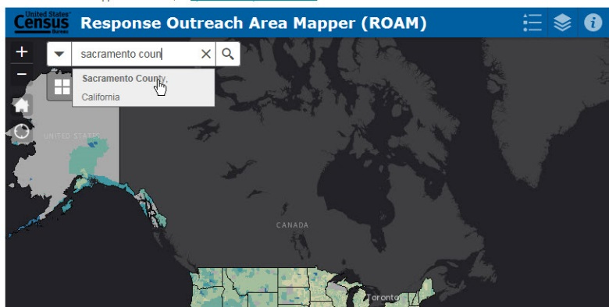
- The Selected area is highlighted. Click ‘X’ to close box and view/access data.
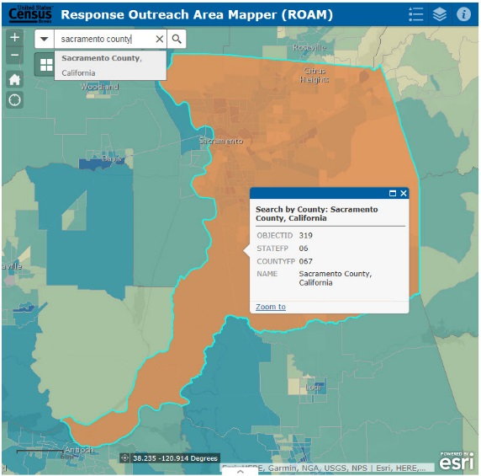
- Tools. Click Layer List and Select ‘Place Layer’ to view city/town layers on the map.
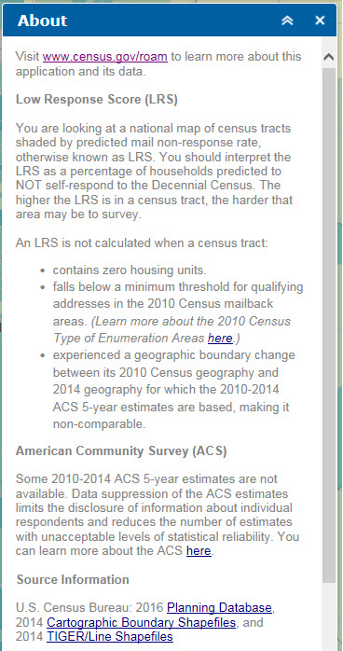
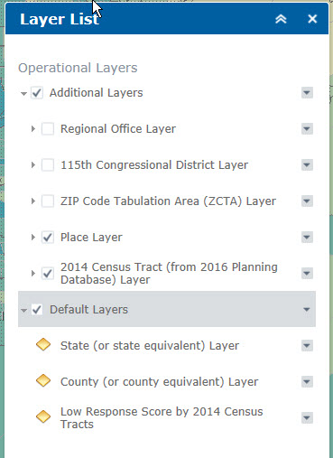
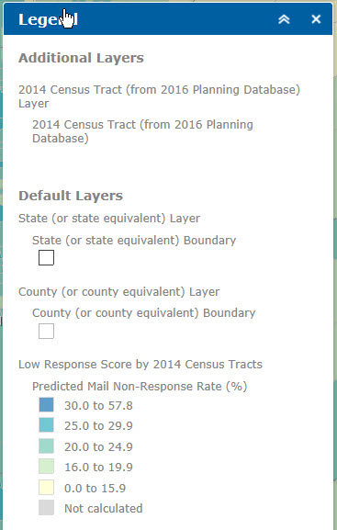

- Zoom-in to view a city (place). Click on a census tract to view information and data.
- Click the right arrow to view census tract data.
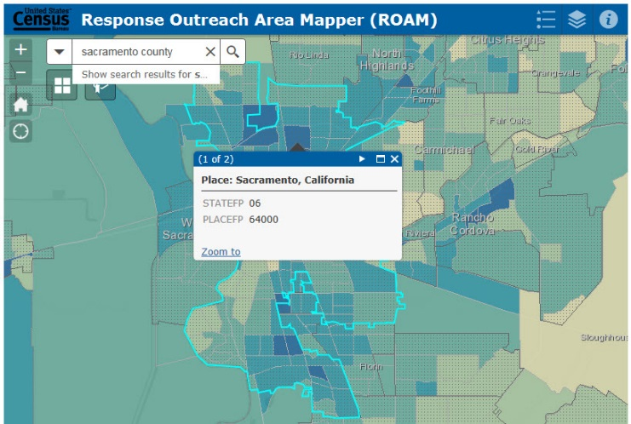
When not zoomed into a particular census tract, multiple selections will appear. In this example, two geographies appear:
(1 of 2) for Sacramento City and (2 of 2) for the selected census tract. Data is only provided at the census tract level.
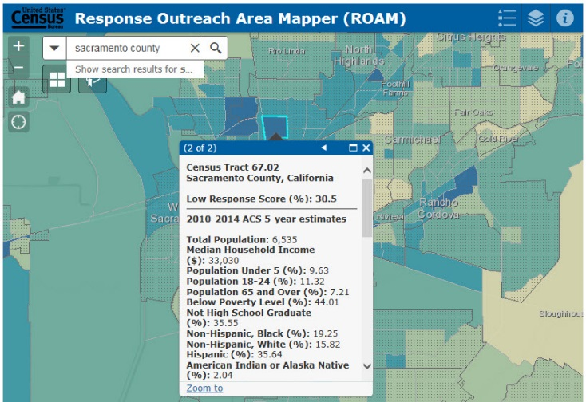
To Expand the View, Click the Window Icon
- To view data and download data for one or more census tracts, click the arrow at bottom of screen.
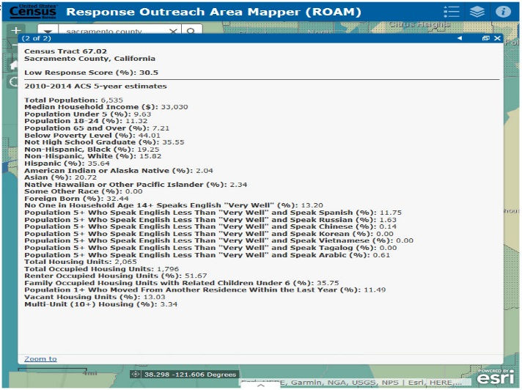

- Scroll Right to view Low Response column. Click column header to sort in ascending/descensing order.
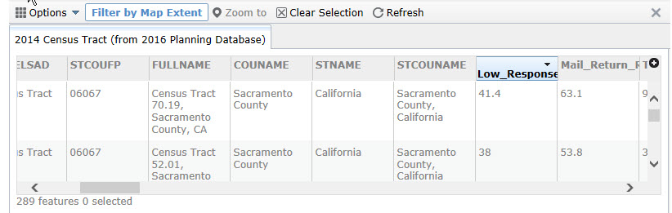
Note: The system will provide data for all the census tracts that appear on your screen. Use the zoom tool to increase or decrease the number of census tracts available.

Steps to filer and view data for census tracts with Low Response Scores of 30 and Higher:
- Click ‘Options’ and ‘Filter’
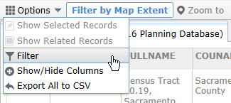
- Click ‘Add a Filter Expression’
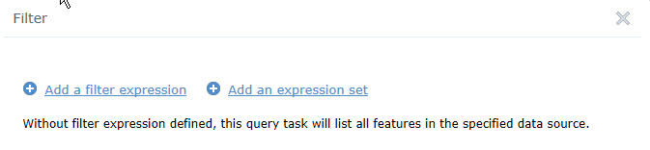

- Select ‘Low Response Score’/ ‘Is at Least’/ ‘30’. Then click ‘Ok’
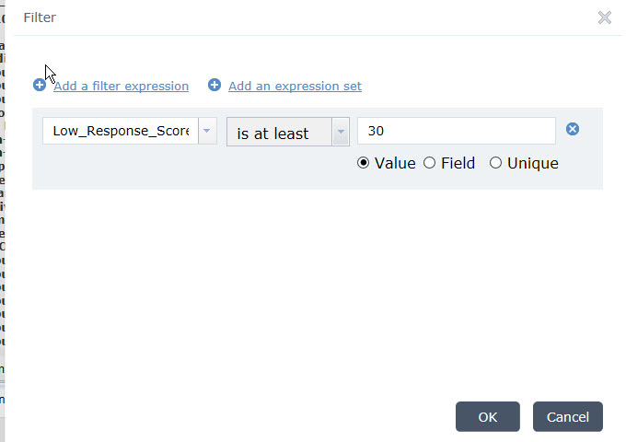

- To download data, Click ‘Options’ and ‘Export All to CSV’
